GEODATE for Windows version 4: Isotope regression and modelling software
by
B.M. eglington

Saskatchewan Isotope Laboratory,
University of Saskatchewan,
Saskatoon, Canada

CONTENTS
Introduction 3
Options available 3
Program requirements 4
Files required 4
Installing GEODATE for Windows 5
Differences between the DOS version of GEODATE and the current Windows version 5
Program operation 6
Data input and editing 7
Importing data from spreadsheets 7
Editing data 9
Calculation of regression dates 11
Calculated uncertainties 14
Calculation of weighted averages and model dates 16
Depleted mantle and uniform reservoir models 17
Lead isotope evolution models 19
Weighted averages 19
Concordia dates 20
Screen graphics 22
Topics available via the Options Menu 22
Alpha level 22
Concordia weight 22
Ellipse magnification 22
F table 22
Pb models 23
Acknowledgements 23
Bibliography and References 24
Appendix A 27

Introduction
This manual documents the operation of GEODATE for Windows (version 4.x), a 32-bit or 64-bit program for the regression and modelling of isotope data. The software has been written for use on microcomputers using Windows 10 and compatible operating systems.
Since this package is supplied free of charge, we request that its use be acknowledged when publishing. Correct reference is:
Eglington, B.M. and Harmer, R.E. (1999). GEODATE for Windows version 1: Isotope regression and modelling software. Council for Geoscience Open-file report 1999-0206 O, 24pp.

Options available
The program is capable of regressing and processing simple X-Y data, Rb-Sr, Sm-Nd, U-Pb, Pb-Pb, Th-Pb, Lu-Hf, La-Ce, radiogenic U-Pb (Wetherill and Tera-Wasserburg approaches), Re-Os, K-Ar, Ar-Ar, evaporation Pb-Pb and Lu-Hf data with errors in both ordinates. Correlation between the errors can also be considered. Regression is based on the techniques of York (1969), Williamson (1968) and Titterington and Halliday (1979). Age, initial ratio and epsilon/gamma values, and their uncertainties, are calculated following the techniques of Ludwig (1980, 1990), Roddick (1987), Harmer and Eglington (1991) and Eglington and Harmer (1993). Concordia dates for radiogenic U-Pb data are calculated following the procedure documented by Ludwig (1998).
Routines are included to maintain and edit data files, and to generate on-screen plots of the regressions, weighted averages and concordia dates. It is also possible to import and export Microsoft Excel spreadsheets.

Program requirements

Files required
The primary application executable, titled GDW4, was written in Delphi (currently version 10.1 Berlin) and uses the TeeChart graphing components from Steema Software and Flexcel spreadsheet components from TMS Software. The software comprises the file GDW4.EXE and various supporting files. Legal copies of all necessary files are automatically installed by the Installaware software which was used to prepare a self-extracting executable installation file. The file GEODATE.INI (in the user’s home roaming directory) is automatically created the first time the program is run. This ASCII text file contains many of the parameter definitions e.g. decay constants utilised within GEODATE for Windows and may be edited by the user, as detailed elsewhere in this documentation.
Data are initially read from Excel spreadsheet files but may then be stored in random access files, separate files being used for each isotopic technique. These files all have the extension ".YK?" where "?" is a numeral in the range 0 to 9 or letter from A to J, corresponding to the analytical codes used in the program. The default versions of these codes are:
0 – general (no isotope system)
1 - Rb-Sr
2 – Sm-Nd
3 - Pb-Pb
4 - ²³⁸U-Pb
5 - ²³⁵U-Pb
6 - Th-Pb
7 - Lu-Hf
8 – radiogenic U-Pb (Wetherill concordia approach)
9 - La-Ce
A – radiogenic U-Pb (Tera-Wasserburg approach)
B – K-Ar
C – Ar-Ar
D – Ar reverse
E – K-Ca
F – Re-Os
G – La-Ba
H – Kober type zircon evaporation lead
I – Ar-Ar plateau
J – Age – Epsilon values used to calculate T(2DM)
These files are compatible with earlier DOS versions of GEODATE (e.g. Eglington and Harmer, 1991).
The structure of the internal .YK? files is described in Appendix A although normal users are never likely to need to access these files other than through the GEODATE interface.

Installing GEODATE for Windows
Installation of GEODATE for Windows is easy. Simply follow the normal Windows 10 approach for adding new software from the Windows Control Panel. Setup options are controlled by the Installaware package which provides a professional interface for selecting the various options available to the user. Most users should accept the default options provided during this installation process. This process will also install and register all the software components required for the software to function in the Windows 10 environment.

Differences between the DOS version of GEODATE and the current Windows version
There have been a number of improvements and changes made since the original DOS version of this software. The main changes are:
- GEODATE now runs in either 32-bit or 64-bit Windows environments, depending on the installation package chosen.
- GEODATE now uses one F cut-off file. The number of replicates used for each data set is stored with the data in the .YK? file or defaults to 999. This modification increases the flexibility of GEODATE since analytical precisions for the various isotope systems and rock suites analysed are frequently defined at different confidence levels.
- Model confidence limits are presented at 95% confidence, not 1 sigma as in early DOS versions of GEODATE. The approach used is the same as for GEODATE (DOS) version 2.2. Remember that these confidence limits are directly related to the number of replicates used to assess analytical uncertainties.
- Model ²³⁸U/²⁰⁴Pb values and model Pb-Pb dates can be calculated for either one common date supplied by the user or for individual dates specified in the ‘Extra’ field of each data record.
- Weighted averages can be calculated for a variety of variables.
- Histograms can be drawn for a variety of variables, including Nd model dates and model ²³⁸U/²⁰⁴Pb values.
- Data defining all screen graphics may be exported to Microsoft Excel spreadsheets for subsequent high quality plotting using packages such as GRAPHER for Windows^{(R)}.
- On-screen graphs may be modified or sent to a printer by right-clicking the image and selecting the appropriate options. Alternatively, they may be saved as metafiles or raster images. It is also possible to modify the appearance of graphs by clicking on the ‘spanner’ icon located above most graphs.
- GEODATE can now perform constrained regressions.
- In addition to the GEODATE file structure used by DOS versions of GEODATE, it is now possible to access Microsoft Excel spreadsheets. The column order for individual isotope systems is stored in the .INI file so that, if one continually uses the same file structure, it is not necessary to define which column matches which variable each time a data set is imported. Users thus use spreadsheet files rather than the .YK? files for all their initial data entry.
- GEODATE for Windows can now also process radiogenic data using the Tera-Wasserburg approach (Tera and Wasserburg, 1972) and can convert data from this format to the Wetherill format or vice versa.
- A number of additional isotope systems have been implemented, including Ar-Ar in various formats.
- It is also possible to calculate T(2DM) model ages from appropriate isotope data or from Age-Epsilon value pairs.
- Weighted concordia dates (Ludwig, 1998) may now be calculated for zircon and other radiogenic U-Pb data.

Program operation
On starting the program, the user is provided with a screen, as illustrated in Figure 1. Menu items available are: File, Edit, Regress, Model, Average, Options and Help. Some of the most commonly used menu items may also be accessed via speed buttons on a tool bar below the menu.
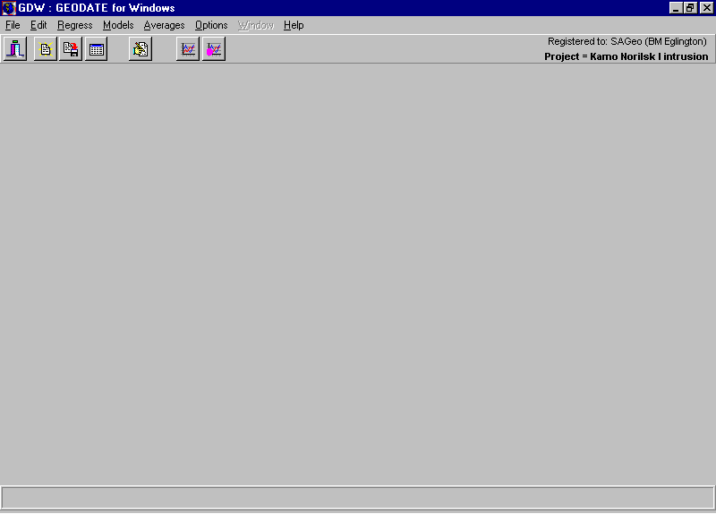
Figure 1. Main window for GEODATE for Windows.

Data input and editing
Initial data entry is expected from Microsoft Excel spreadsheets (Excel 2013 .XLSX format or 2007 .XLS format), after which data may be stored in the internal .YK? format files. Subsequent data use is normally based on these internal files.

Importing data from spreadsheets
Initial data entry is done by importing from Excel spreadsheets. Figure 2 illustrates the dialog provided when one chooses to import data from an Excel spreadsheet. Once a spreadsheet has been opened (click on the Open button at the top of the window and select the file you want), the user needs to specify which rows to import and the columns in which the various fields will be found. One must also specify the isotope system so that GEODATE knows what to call each column. Once one is happy with the specifications, click the Import button, data are imported and are presented in the standard Edit Data window. Thereafter, the user is prompted for the name of a GEODATE file in which to store the data.
The column specifications for each isotope system are stored in the GEODATE.INI file. If one uses the same format for other data sets, then it is not necessary to specify the column setting when performing subsequent imports. The ease of operation of this option now makes it feasible to use spreadsheets as the primary data file in place of the customised GEODATE files.
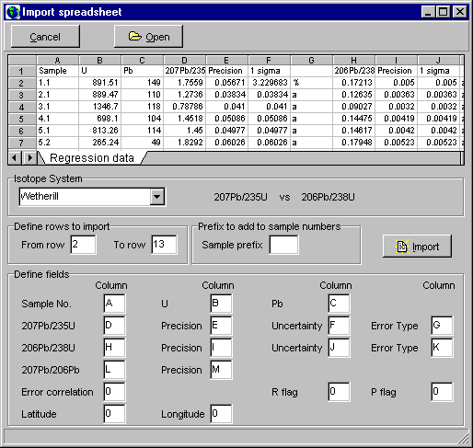
Figure 2. Spreadsheet import window. After opening an Excel spreadsheet, one selects the appropriate isotope system and then defines the starting and ending rows to be imported and the columns in which the various data are stored. These column settings will be remembered for future use so as to minimise user input requirements if the same spreadsheet layout is used for other data.

Editing data
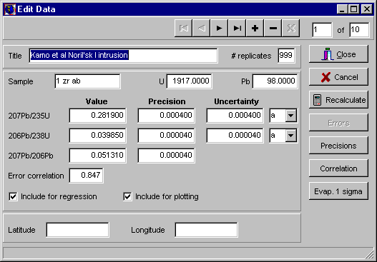
Figure 3. Window for editing of data. All editing is held in memory and the original data file is not automatically updated. The user should save changes as necessary.
For some isotope systems (e.g. Rb-Sr) the operator may choose to have the program calculate the relevant X/Y atomic ratio for each sample. X/Y atomic ratios are calculated as follows:
⁸⁷Rb/⁸⁶Sr = Rb/Sr _{ppm} (2.692948 + 0.283040*⁸⁷Sr/⁸⁶Sr)
¹⁴⁷Sm/¹⁴⁴Nd = Sm/Nd_{ppm} (0.531497 + 0.142521*¹⁴³Nd/¹⁴⁴Nd)
¹⁷⁶Lu/¹⁷⁷Hf = Lu/Hf_{ppm} (0.134399 + 0.025983*¹⁷⁶Hf/¹⁷⁷Hf)
¹³⁸La/¹⁴²Ce = La/Ce_{ppm} (0.00811)
These, and other, values are based on the atomic masses provided by Wapstra and Bos (1977), but may be changed in file GEODATE.INI in the Windows folder.
The program expects all analytical uncertainties to be expressed as one sigma values, either as % or actual, according to the procedure used at one's laboratory. Blanket uncertainties may be chosen during data input. The uncertainties specified will be used for each of the samples and can thus reduce the amount of typing required. Obviously, this option would only be used if all the samples do, in fact, have the same uncertainties, expressed in the same way.
If the concentrations are changed during editing, the operator may choose to have the program recalculate the relevant X/Y atomic ratio (using formulae such as those presented above) by clicking on the ‘Recalculate’ button. The operator will be asked whether to accept the new value or not if it is significantly different from that already available.
Analytical uncertainties for regressions, weighted averages, etc may be derived from the precisions associated with each X and Y measurement. This is of particular use when importing SHRIMP U-Pb data from the spreadsheets typically used for reporting. In this case, a dialog (Figure 4) is presented, prompting the user to select the variable concerned and the nature of the original precision. This process needs to be done for each individual record in the data set.
Figure 4. Dialog for calculating analytical uncertainties from precisions. | 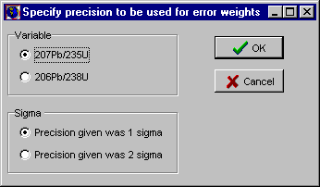
It is also possible to calculate the error correlation for radiogenic U-Pb and Pb-Pb data from the precisions and values provided if appropriate variables are stored in the ‘Extra’ variable and its precision. For Pb-Pb and Wetherill-type radiogenic U-Pb data this should ²⁰⁷Pb/²⁰⁶Pb. Calculation follows the formulation of Ludwig (1980, 1998).
It is sometimes possible to obtain within-run precisions for zircon evaporation data which are significantly better than between-run (external) precisions. It is thus possible to specify a minimum permissible percentage uncertainty for these data by clicking on the Evap. 1 sigma button in the Edit Data window. The user is then prompted for a minimum value, as illustrated in Figure 5
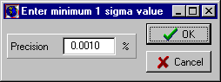 | Figure 5. Dialog for specifying the minimum percent analytical uncertainty allowed for zircon evaporation results.
Data may be included or excluded from the regression by means of the 'Regress Flag' option in the Edit Menu. Any point excluded from a regression will not be deleted from the file but will appear separately on the printout.
Once initial spreadsheet importing is complete, the operator is prompted for the name of a GEODATE type file in which to store the data. Thereafter, if changes are made, it is up to the operator to save the modified file. Changes are not automatically updated in the file!

Calculation of regression dates
Regression of data in this software follows the techniques of York (1969), Williamson (1968), Titterington and Halliday (1979) and Ludwig (1980, 1990). Uncertainties in the "X" and "Y" ordinates, together with their error correlation, are taken into account. Error correlation in U-Pb studies should be consistent with the equations of Ludwig (1980). The procedure cycles until the difference between two successive slopes is less than 0.000001 or the number of iterative cycles exceeds 200.
Dates for standard isochron type techniques (e.g. Rb-Sr, Sm-Nd), derived from the best-fit line, are calculated by substitution of the slope of the line into the equation:
ln(slope +1)
t = --------------
λ
Pb-Pb dates are determined by Newton's iterative technique, following regression. Iteration continues until two successive dates differ by less than 1,000 years.
Default decay constants used are:
⁸⁷Rb = 1.42 x 10⁻¹¹ a⁻¹
¹⁴⁷Sm = 6.54 x 10⁻¹² a⁻¹
²³⁸U = 1.55125 x 10⁻¹⁰ a⁻¹
²³⁵U = 9.8485 x 10⁻¹⁰ a⁻¹
²³²Th = 4.9475 x 10⁻¹¹ a⁻¹
¹⁷⁷Lu = 1.867 x 10⁻¹¹ a⁻¹
¹³⁸La = 2.33 x 10⁻¹² a⁻¹
¹⁸⁷Re = 1.666 x 10⁻¹¹ a⁻¹

These, and other values, may be changed in the GEODATE.INI file in the user’s home, roaming folder.
Radiogenic U-Pb data (Wetherill and Tera-Wasserburg concordia approach) may be regressed according to three methods. The operator may choose the standard technique where weighting is identical to that used in the Rb-Sr system, or may choose to augment the errors according to the degree of discordance of the points relative to the upper or lower concordia intercepts. In these cases the data are augmented following the formulation of Ludwig (1990) but with "p" initially held to a value of 0.2 (Eglington and Harmer, (1993). Figure 6 illustrates the dialog used to select the weighting approach for these situations.
Figure 6. Dialog used to specify the regression weighting approach to be used for radiogenic U-Pb data. | 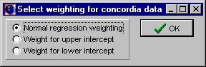
Concordia intercept dates are derived following the approach of Ludwig (1980). Here too, successive dates must differ by less than 1,000 years before the procedure used returns a value.
Typical regression results for isochron data and radiogenic U-Pb data are illustrated in Figure 7 and Figure 8, respectively. It is also possible to calculate regressions constrained to pass through some point specified by the user. The approach used to calculate this form of regression is to use the X and Y values of the constraining point as the centroid of the line. The regression uncertainties obtained in this way are believed to be more realistic than those calculated by ‘adding’ an extra precisely-defined point since this latter methodology increases the spread in the data and thus artificially reduces the regression uncertainties (Harmer and Eglington, 1991).
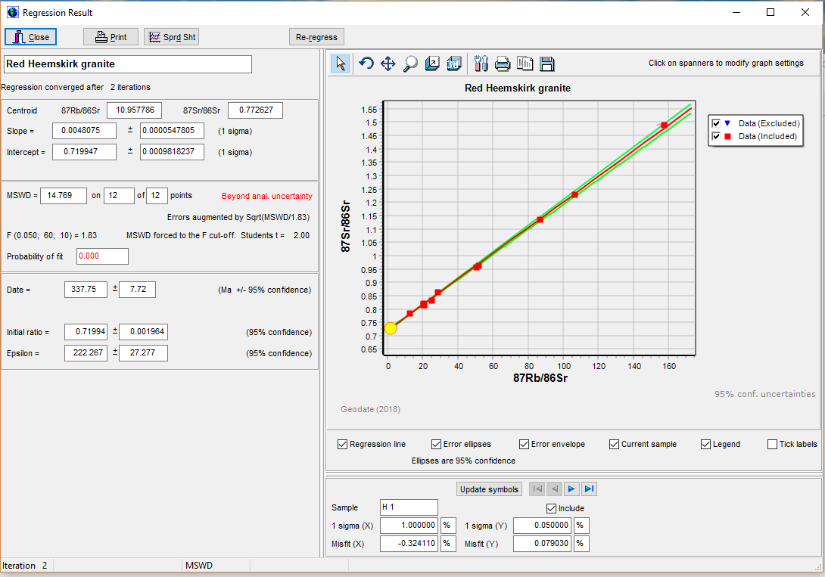
Figure 7. Regression result window for typical isochron data, in this case Rb-Sr. Data are illustrated graphically (red symbols for points included in the regression and blue symbols for those excluded). The user may step through the data by clicking on the navigator bar below the graph. The current sample is highlighted in a large yellow square. Results may be printed or saved in an Excel spreadsheet.

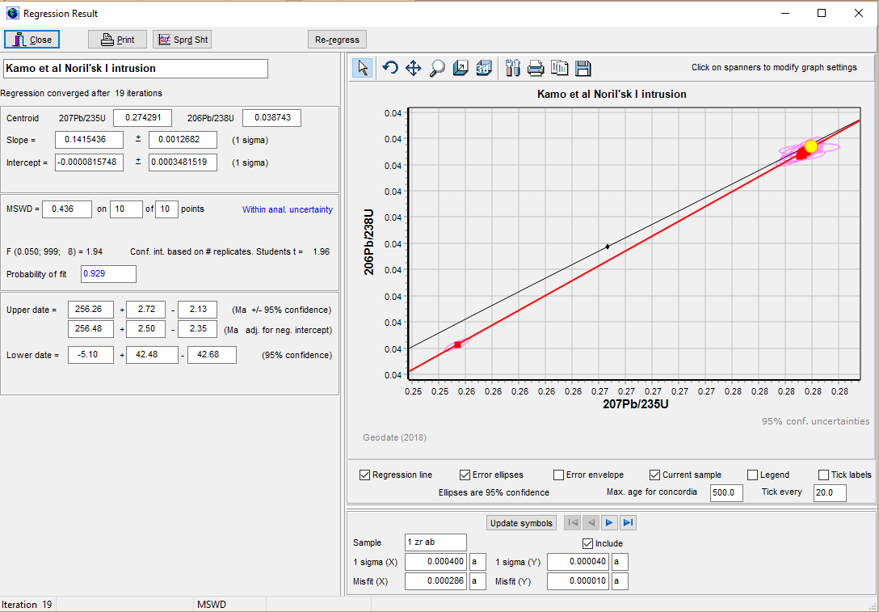
Figure 8. Regression result window for Wetherill type radiogenic U-Pb data. Data are illustrated graphically (red symbols with magenta error ellipses for points included in the regression and blue symbols and ellipses for those excluded). If the user requires that the spreadsheet also contain the co-ordinates of the error ellipses, then the ‘Error ellipse’ check box beneath the graph must be checked prior to saving to spreadsheet.

Calculated uncertainties
Errors calculated for isochrons by GEODATE are based on the approach of York (1969) but, where the MSWD exceeds the specified Critical F value, the operator is prompted to choose one of a number of models with which to treat the data, as illustrated in Figure 9.
Figure 9. Dialog used to select the errorchron enhancement approach to be used when MSWD > F. | 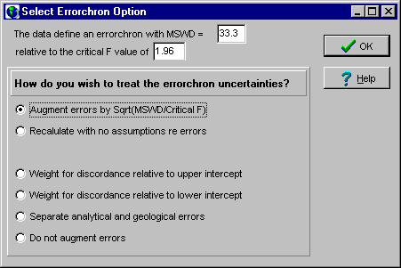

Options are:
- augment uncertainties by the square root of MSWD/Critical F. Mathematical details of this approach have been summarised by Harmer and Eglington (1991). The Student's t multiplier for 95% confidence estimation is derived (formula from Ludwig, 1983, 1990) from the number of replicates utilised to define the analytical uncertainties.
- follow Ludwig's (1983) Model 2 approach in which no assumptions are made as regards analytical uncertainties and error correlation is assumed to be 0.0. This technique, as implemented here, forces the MSWD to a value of 1.0. The Student's t multiplier for 95% confidence estimation is derived from the number of samples regressed, not from the number of replicates utilised to define the analytical uncertainties.
- an option based on Model 3 of Ludwig (1983,1990) and only available for standard isochron decay schemes (e.g. Rb-Sr, Sm-Nd). Excess scatter is assumed to be due to normally distributed variation in the initial ratios of the samples, in addition to their analytical uncertainties. The model requires the assumption that the sample initial ratios were not correlated with the parent/daughter ratios. The Student's t multiplier for 95% confidence estimation is derived from the number of samples regressed, not from the number of replicates utilised to define the analytical uncertainties. Calculation iterates until MSWD is forced to the chosen Critical F value.
- Ludwig's (1990) model 4 approach for radiogenic U-Pb (concordia) data in which analytical uncertainties are continually augmented relative to the discordance of the point until MSWD is equal to the Critical F value. This is achieved by increasing the value of "p". The Student's t multiplier is derived from a weighted sum of the number of samples regressed (n_{r}) such that this sum will always be less than n_{r}.
- an option proposed by Harmer and Eglington (1991) as being intuitively more appropriate for isochron type decay schemes. This model assigns separate analytical and 'scatter' components contributions to errorchron regression errors according to the following formulae:
σ²(excess) = σ²(analytical) * (MSWD/F critical - 1)
- where uncertainties are not augmented to account for scatter in excess of that explained by analytical uncertainty. 95% confidence intervals are based on a Student's t value derived from the number of replicates used to define the analytical uncertainties. This approach will always provide an underestimate of the calculated uncertainties for errorchrons.
For the standard isochron techniques, age errors are determined using the same equation as that used for the calculation of the age. Concordia intercept age errors are determined by means of the equations presented by Ludwig (1980). Pb-Pb age errors are determined by substitution of the adjusted (plus or minus) slopes into equations similar to those used to derive concordia intercept uncertainties.
Source Pb-Pb growth-curves are calculated assuming either a single stage (starting at 4.57 Ga) or Stacey and Kramers (1975) two-stage model (3.7 Ga starting point). Details of the mathematics are presented in Appendix E. The user may select the model to be used from the Options Menu. Errors associated with these curves are calculated using the error envelope approach of Ludwig (1980), as explained in Appendix E. All these procedures are iterative and two successive æ values must differ by less than 0.0002 before a value is returned to the calling routine.

Calculation of weighted averages and model dates
These menu items permit the calculation of model uniform reservoir; depleted mantle; initial ratio; epsilon/gamma or model source ²³⁸U^{/204}Pb values, model ²⁰⁷Pb/²⁰⁶Pb and weighted averages for each of the three measurement variables provided. Several of the calculations may be performed for the same date or initial ratio for all records or for a date specified in the extra variable field. It is also possible to calculate weighted average concordia dates (Ludwig, 1998).

Depleted mantle and uniform reservoir models
Model depleted mantle and uniform reservoir evolution is described by equations of the form
ratio = at² + bt + c
where t is the age in years. The parameters a, b and c are specified in the GEODATE.INI file for each decay system and may be modified by the user using any ASCII text editor..
Default T_{DM} dates for Sm-Nd and Rb-Sr, etc are based on equations of the form Ben Othman et al. (1984) or De Paolo (1991) whereas T_{UR} dates are based on the following constants:
⁸⁷Rb/⁸⁶Sr = 0.0847 ⁸⁷Sr/⁸⁶Sr = 0.7047
¹⁴⁷Sm/¹⁴⁴Nd = 0.1967 ¹⁴³Nd/¹⁴⁴Nd = 0.51264
¹⁷⁶Lu/¹⁷⁷Hf = 0.0334 ¹⁷⁶Hf/¹⁷⁷Hf = 0.28286
¹³⁸La/¹⁴²Ce = 0.00306 ¹³⁸Ce/¹⁴²Ce = 0.0228527
These, and other values, may also be changed in the GEODATE.INI file in the Windows folder.
Example results, utilising Sm-Nd data, are illustrated in Figure 10 and Figure 11. In both examples, there is substantial scatter in the data, producing large MSWD values with an effective 0.0 probability that the data represent a uniform population.
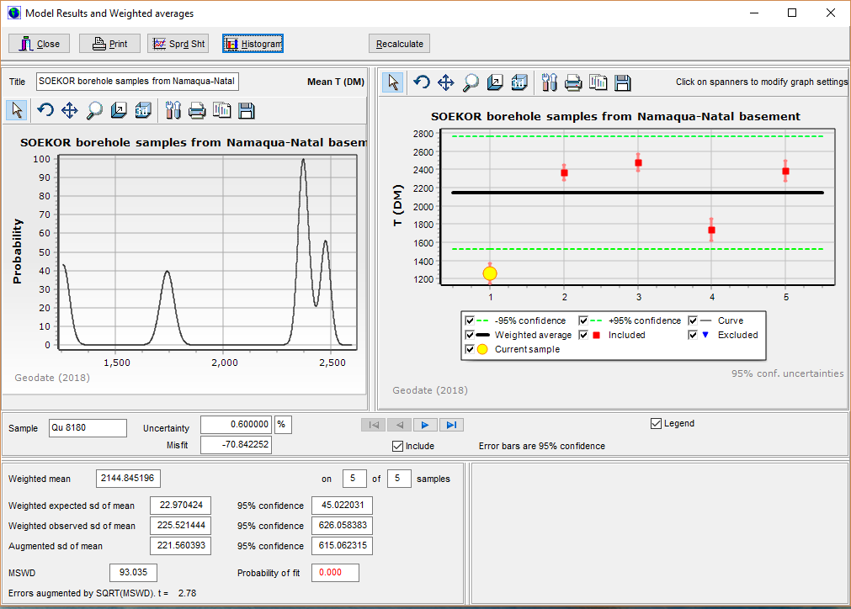
Figure 10. Weighted average T(DM) values for Sm-Nd data.
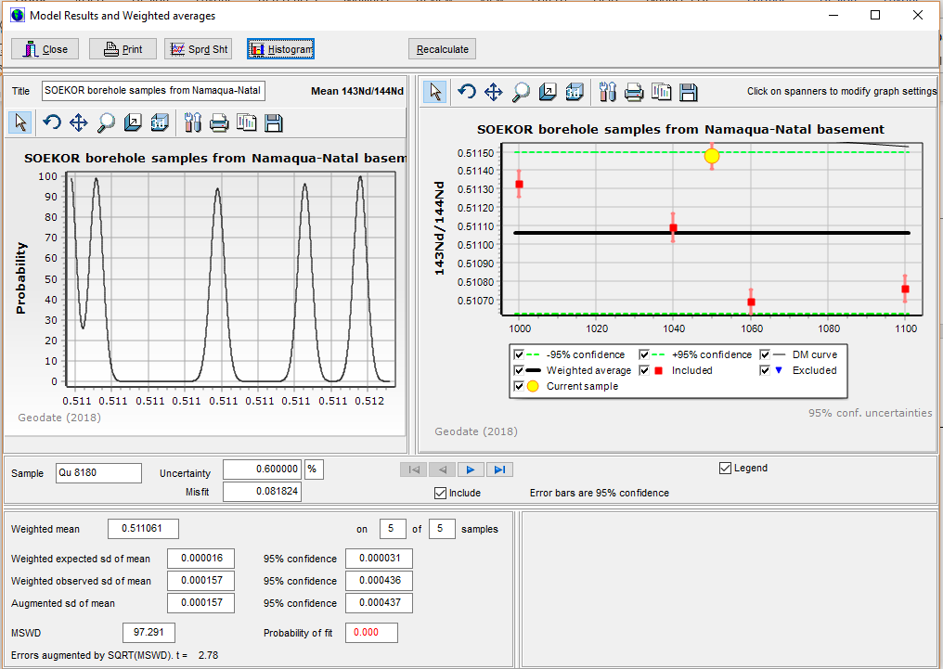
Figure 11. Weighted average initial ¹⁴³Nd/¹⁴⁴Nd data.

Lead isotope evolution models
The user may specify up to three lead isotope evolution systems in the .INI file. One is assumed to represent a single stage model, another a two stage model and the third may be any user defined model which matches the simple formulation:
ratio = initial ratio + ²³⁸U/²⁰⁴Pb (e^{λt} – 1)
for ²³⁸U decay and similarly for ²³⁵U and ²³²Th.

Weighted averages
Weighted averages are automatically calculated for all models selected and are presented in a window such as that illustrated in Figure 12.
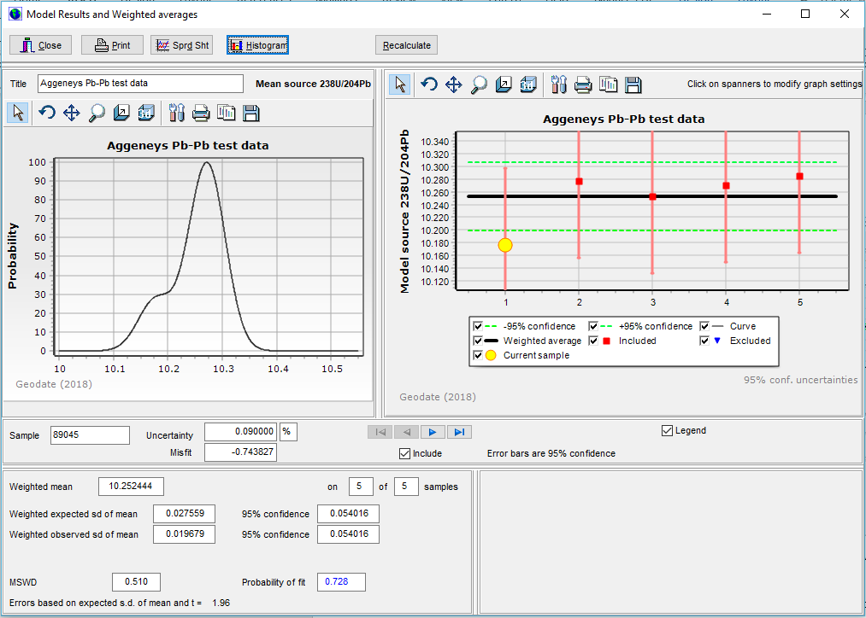
Figure 12. Weighted average calculated for the model selected, in this case model ²³⁸U/²⁰⁴Pb for common Pb data from the Aggeneys ore deposit.
Errors calculated for initial ratios or epsilon values (at a given age) are based on the error propagation formulation of Roddick (1987). A similar approach has been used to calculate the uncertainties for model dates when assuming some initial ratio.
In all cases, the pooled uncertainties for a number of "included" data points is calculated as the greater of the standard deviation of the values or the pooled standard error. Weighted averages for these parameters are calculated following the techniques of Claoue-Long (1989) and Eglington and Harmer (1993).

Concordia dates
Concordia dates (Ludwig, 1998) may also be calculated for radiogenic U-Pb data. The results of these calculations are illustrated in Figure 13.
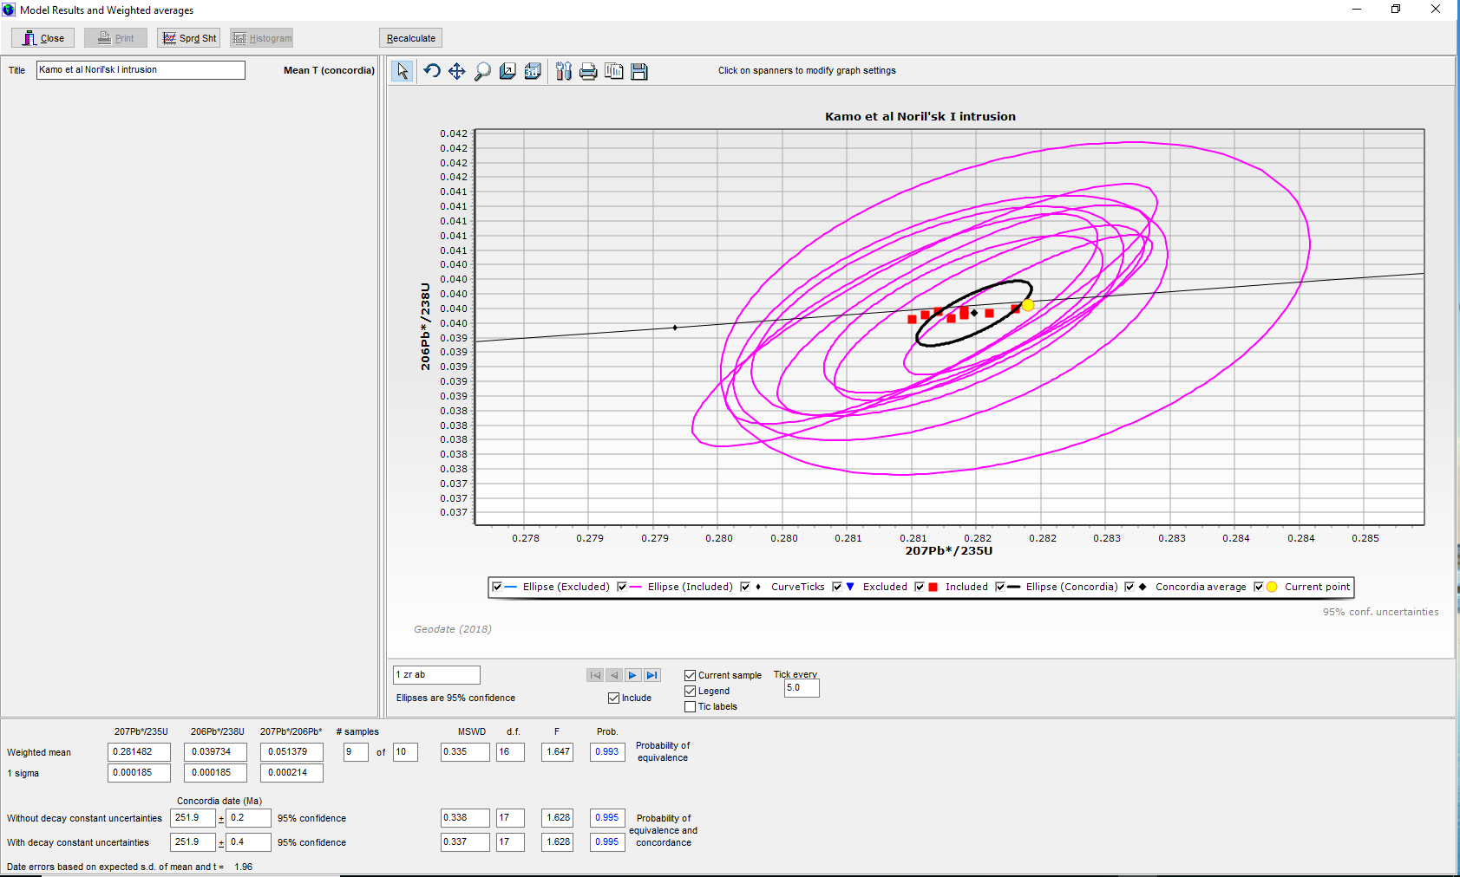
Figure 13. Concordia date for the Noril’sk data of Kamo et al. (1996). These data are shown to be statistically equivalent (probability of equivalence = 0.172) but their weighted concordia date is not within error of the concordia curve if decay constant uncertainties are ignored.
Comparison of calculations for Geodate and Isoplot are provided in Table 1.

Table 1. Comparison of results for GEODATE with results provided by other software, primarily Isoplot.
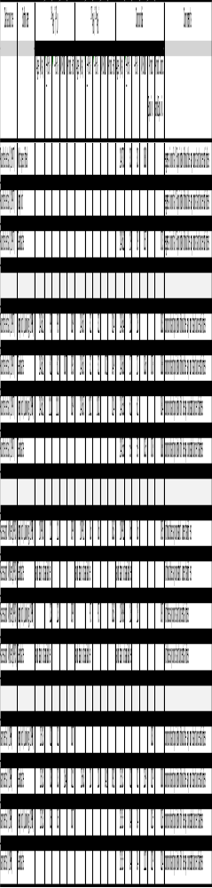

Screen graphics
Graphical representations of the data are provided or may be created by the user after providing additional information e.g. for histogram plots. All graphs may be modified by clicking on the ‘spanner’ icon above the graph and following the menu options provided. Default colours for the graphs may be changed in the GEODATE.INI file.

Topics available via the Options Menu
A number of default options may be set from this menu. These include:

Alpha level
This sets the alpha level to be used for statistical tests, for instance alpha = 0.05 for a 5% level of significance which is normally taken as 95% confidence.

Concordia weight
Here, one may specify the default concordia weighting option. It may be either Normal or Discordance.

Ellipse magnification
This option sets the magnification factor to be used for the graphing of data using ellipses. The user may select between 1 sigma or 95% confidence error ellipses.

F table
The F table provides the data for use in assessing whether scatter in regressions and weighted averages is within analytical uncertainty or not. One may have values in the table (illustrated in Figure 14) for various combinations of alpha level, number of replicates and number of samples. The specific alpha level to be applied is specified under the Alpha level sub-menu of the main Options Menu and is also read from the GEODATE.INI file whilst the number of replicates defaults to 999 for new data and may be changed in the Edit Data window.
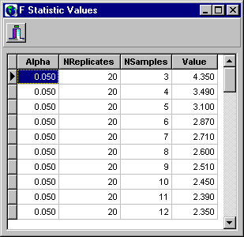 | Figure 14. Dialog for specifying the F variate values for different combinations of alpha level, number or replicates and number of samples.

Pb models
This specifies the default lead isotope evolution model to use. It may be one of either: Single stage, S+K 2 stage (Stacey and Kramers, 1975 two-stage model), or some other user defined model.

Acknowledgements
I thank the many fellow staff and isotope colleagues throughout Canada, South Africa and internationally who have tested earlier versions or contributed suggestions to make this a better package. In particular I thank Jock Harmer, Moose Kruger, Rich Armstrong and Jan Kramers. I have also benefited greatly from communication with Ken Ludwig and Sam Bowring. This software has been developed with the support of the University of Saskatchewan, NSERC and, previously, the Council for Geoscience in South Africa.

Bibliography and References
Ben Othman, D., Polv, M. and Allegre, C.J. (1984). Nd-Sr isotopic composition of granulites and constraints on the evolution of the lower continental crust. Nature, 307, 510-515.
Brooks, C., Hart, S.R. and Wendt, I. (1972). Realistic use of two-error regression treatments as applied to rubidium-strontium data. Rev. Geophys. Space Physics, 10, 551-577.
Cahen, L., Snelling, N.J., Delhal, J. and Vail, J.R. (1983). The geochronology and evolution of Africa, Clarendon Press, Oxford, 512pp.
Cumming, G.L. (1969). A recalculation of the age of the solar system. Can. J. Earth Sci., 6, 719-735.
Cumming, G.L., Rollett, J.S., Rossotti, F.J.C. and Whewell, R.J. (1972). Statistical methods for the computation of stability constants. Part I. Straight-line fitting of points with correlated errors. J. Chem. Soc., Dalton Transactions, 23, 2652- 2658.
Davis, D.W. (1982). Optimum linear regression and error estimation applied to U-Pb data. Can. J. Earth Sci., 19, 2141- 2149.
DePaolo, D.J., Linn, A.M. and Schubert, G. (1991). The continental crustal age distribution: methods of determining mantle separation ages from Sm-Nd isotopic data and application to the southwestern United States. J. Geophys. Res., 96, 2071-2088.
Eglington, B.M. and Harmer, R.E. (1993). A review of the statistical principles of geochronometry: II. Additional concepts pertinent to radiogenic U-Pb studies. S. Afr. J. Geol., 96, 9-21.
Faure, G. 1986. Principles of isotope geology. 2nd Edn. John Wiley, New York, 589pp.
Harmer, R.E. and Eglington, B.M. (1991). A review of the statistical principles of geochronometry: towards a more consistent approach for reporting geochronological data. S. Afr. J. Geol., 93, 845-856.
Hart, R.J., Welke, H.J. and Nicolaysen, L.O. 1981. Geochronology of the deep profile through Archean basement at Vredefort, with implications for early crustal evolution. J. Geophys. Res., 86, B 10663-10680.
Kamo, S.L., Czamanske, G.K. and Krogh, T.E. (1996). A minimum U-Pb age for Siberian fload-basalt volcanism. Geochim. Cosmochim. Acta, 60, 3505-3511.
Kent, J.T., Watson, G.S. and Onstott, T.C. (1990). Fitting straight lines and planes with an application to radiometric dating. Earth Planet. Sci. Lett., 97, 1-17.
Ludwig, K.R. (1980). Calculation of uncertainties of U-Pbisotope data. Earth Planet. Sci. Lett., 46, 212-220.
Ludwig, K.R. (1983). Plotting and regression programs for isotope geochemists, for use with HP-86/87 microcomputers. U.S.G.S. Open-file Report 83-849, 94pp.
Ludwig, K.R. (1990). ISOPLOT: a plotting and regression program for radiogenic-isotope data, for IBM-PC compatible computers. Version 2.03. U.S.G.S. Open-file Report 88-557, 45pp. (supplied with source code).
Ludwig, K.R. (1998). On the treatment of concordant uranium-lead ages. Geochim. Cosmochim. Acta, 62, 665-676.
McIntyre, G.A., Brooks, C., Compston, W. and Turek, A. (1966).The statistical assessment of Rb-Sr isochrons. J. Geophys. Res., 71, 5459-5468.
Patchett, P.J. and Tatsumoto, M. (1980). Lu-Hf total-rock isochron for the eucrite meteorites. Nature, 288, 571-574.
Roddick, J.C. (1987). Generalised numerical error analysis with applications to geochronology and thermodynamics. Geochim. Cosmochim. Acta., 51, 2129-2135.
Stacey, J.S. and Kramers, J.D. 1975. Approximation of terrestrial lead isotope evolution by a two-stage model. Earth Planet. Sci. Lett., 26, 207-221.
Steiger, R.H. and J„ger, E. (1977). Subcommission on Geochronology: convention on the use of decay constants in geo- and cosmochronology. Earth Planet. Sci. Lett., 36,359-362.
Tanaka, T. and Masuda, A. (1982). The La-Ce geochronometer: a new dating method. Nature, 300, 515-518.
Titterington, D.M. and Halliday, A.N. (1979). On the fitting of parallel isochrons and the method of maximum likelihood. Chem. Geol., 26, 183-195.
York, D. (1966). Least-squares fitting of a straight line. Can. J. Physics, 44, 1079-1086.
York, D. (1969). Least-squares fitting of a straight line with correlated errors. Earth Planet. Sci. Lett., 5, 320-324.
Wapstra, A.H. and Bos, K. (1977). The 1977 atomic mass evaluation Part 1. Atomic mass table. Atomic Data and Nuclear Data Tables, 19, 177-214.
Welke, H. and Nicolaysen, L.O. 1981. A new interpretative procedure for whole rock U-Pb systems applied to the Vredefort crustal profile. J. Geophys. Res., 86, B, 10681-10687.
Wendt, I. (1984). A three-dimensional U-Pb discordia plane to evaluate samples with common lead of unknown isotopic composition. Isotope Geoscience, 2, 1-12.
Williamson, J.H. (1968). Least-squares fitting of a straight line. Can. J. Physics, 46, 1845-1847.

Appendix A

Record zero of each file contains a title for the data set whilst the data is stored in record 1 ... MaxSamples. The maximum number of samples permitted is usually 5,000, but can vary according to the version provided. Note that few users will ever need to directly access the structure documented below. Most users will start with data compiled as rows in Excel spreadsheets, as documented later in this manual and internal data file storage will be transparent to the user. The internal GEODATE data record structure is as follows:
DataRecord = record
case integer of
1 : (Sano : string[10];
XElemConc, YElemConc, XRatio, XPrecis,
XError, YRatio, YPrecis, YError, Correl : 6 byte real;
AnTyp : char;
ErTyp : char;
RFlag : char;
PFlag : char;
ZRatio, ZPrecis, ZError : 6 byte real);
2 : (Tit : string[80];
NRep : integer;
sparefield : array[1..45] of byte);
end;

Most of the fields constituting these records are self explanatory, those which might require some explanation are:
AnTyp - analytical type (0 .. 9, A..J)
ErTyp - error type (1 .. 4) | 1 = % X error and % Y error  2 = % X error and actual Y error  3 = actual X error and % Y error  4 = actual X and Y errors
RFlag – regress flag | Y = include for regression  N = exclude from regression
PFlag – plot flag (affects screen plotting output and export files) | Y = include for plots  N = exclude from plots
ZRatio, ZPrecis and ZError are extra variables needed in some of the isotope systems. For instance ²⁰⁷Pb/²⁰⁶Pb and its uncertainty is required in the Pb-Pb and concordia systems in order to calculate the error correlation coefficient (see later).
NRep is the number of replicates used or assumed to define the analytical uncertainties and F cutoff value. Usually this will be 999 (an approximation for infinity).

